27th June 2022

Re: Closure of Ulster Bank and KBC Accounts

Dear ,

As you may be aware Ulster Bank and KBC are withdrawing from the Irish market and have commenced their notification process with their account holders. The NSSO is writing to all retirees on our pension payroll with accounts in the above banks to assist our customers in updating their bank details.

A Change of Bank Details form is included with this letter. Please complete the form and return by email or post to the address as shown on the form, as soon as possible.

To ensure continuity of payment customers are advised, where possible, not to close their old account until a payment is received in their new account.

Guidance on how to move accounts as well as a tool to compare different accounts are available on the Competition and Consumer Commission website: www.CCPC.ie

Yours sincerely,

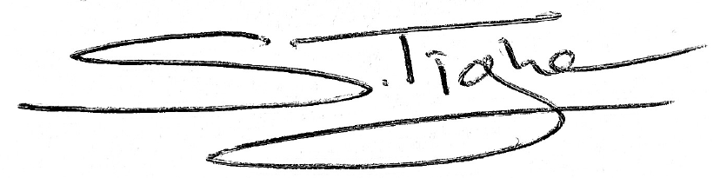
Stephen Tighe,

Pensions Operations Manager
Payroll Services
National Shared Services Office

