NEW!!! ACCESS TO PAYSLIPS FOR RETIREES PAID BY THE PAYROLL SHARED SERVICES

The Payroll Shared Services (PSS) Division of the National Shared Services Office (NSSO) has updated their online CORE Portal system in March 2021 and access to online payslips is more user friendly as a result. The following is a guide to viewing payslips online on the Payroll Shared Services (PSS) website. Thank you to the staff of PSS for their assistance in compiling this information and providing sample screenshots.

- Go to the website https://pssc.gov.ie/.
(Please Note: do not put www before it; you can just type pssc.gov.ie)

- Select the Option ‘View Retiree Online Payslips’.

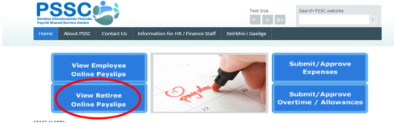

- Select your option from the list:

Unless you are a retired Garda Síochána or a Military Retiree - click on Civil and Public Service Retirees.
(Please note: this update is for payees who are paid by PSS only)

- Enter your User Name, that is, your Pension Number – which is called Personnel Number on your payslip - and your Password and click Sign In.

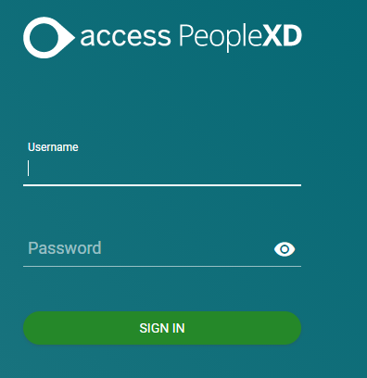
  - If you have forgotten your password, contact helpdesk@pssc.gov.ie.
    - Ensure to provide two pieces of data protection information when doing so. In line with Data Protection, the PSS requires two of the following to verify your account: PPS Number, Personnel Number, or Date of Birth. You should also state which retiree cohort you belong to.

  - You will be required to change your password every 6 months, so keep a note of your latest password and information on how to change your password can be found on the PSS website https://pssc.gov.ie.

    - Select Password/Registration guide from the green boxes at the bottom of the landing page.

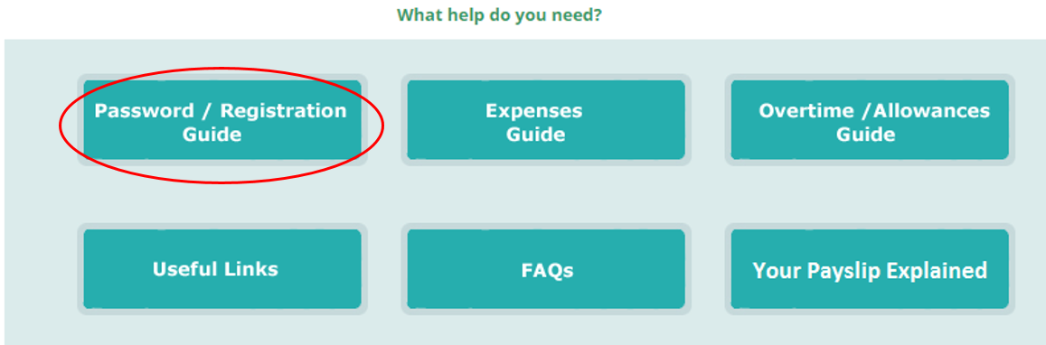

    - Select Why is the system asking me to change my password retirees from the Password/Registration Guide for Retirees.

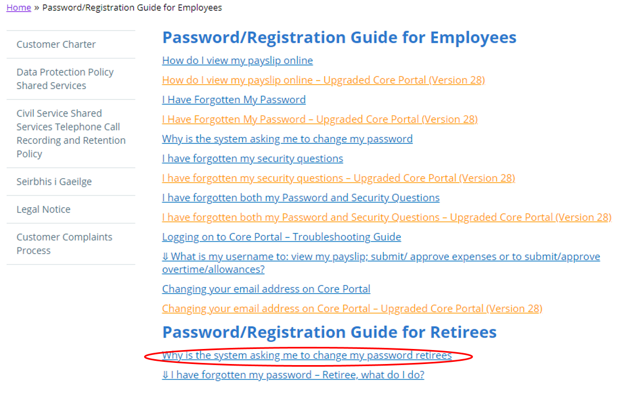

If you are required to change your password, you will be asked to enter your current password, then enter your new password and confirm it. Your new password must be a minimum of 5 characters, consisting of a combination of numeric and letter values. The password must vary from any password set previously for the account.

- When you have successfully logged in, you will automatically be directed to the Employee Dashboard. You will a see a My Payslips section which will show summary of your six most recent payslips (or five most recent and your forthcoming payslip, depending on the timing).

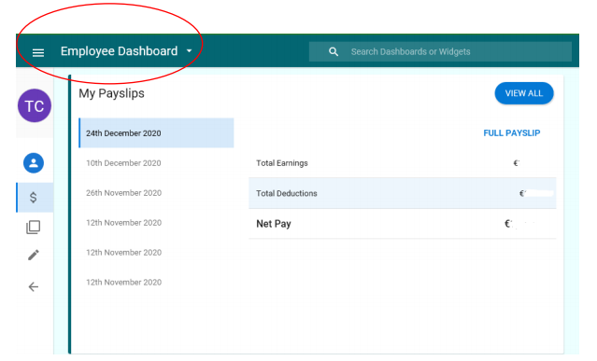

- In the My Payslips section, if you click on Full Payslip, your detailed payslip will open, showing the amounts of deductions, including cumulative Year to Date figures.

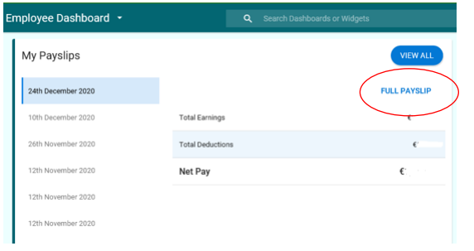

- You will see Select Language Options, where you can select to have the payslip displayed in Irish or English.

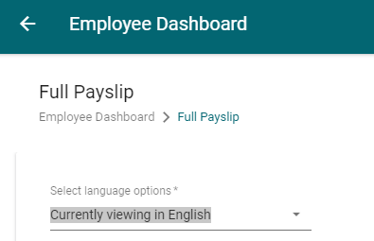

- To print your payslip – select Download PDF located on the bottom right hand side of the screen shot below.

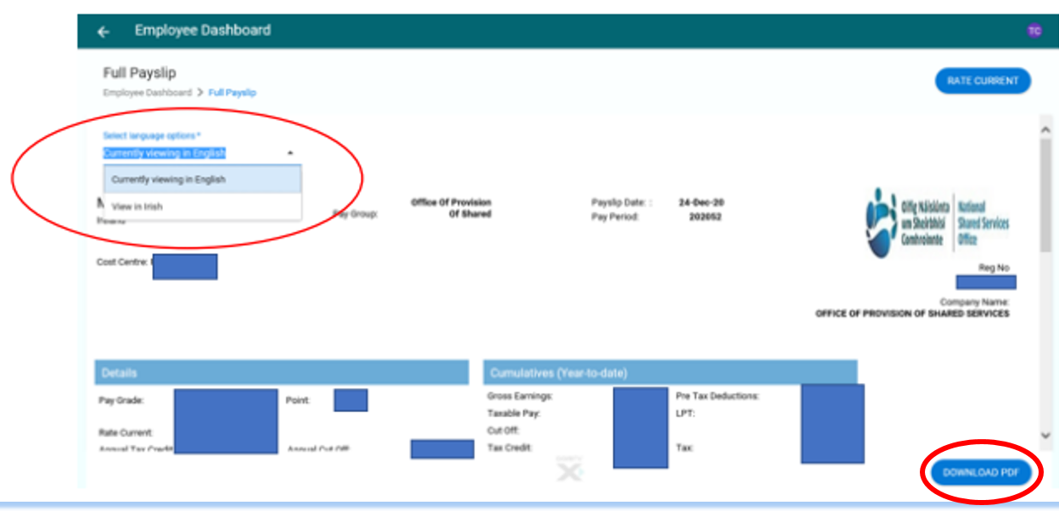

- To View Historic Payslips click on View All on the All My Payslips page.

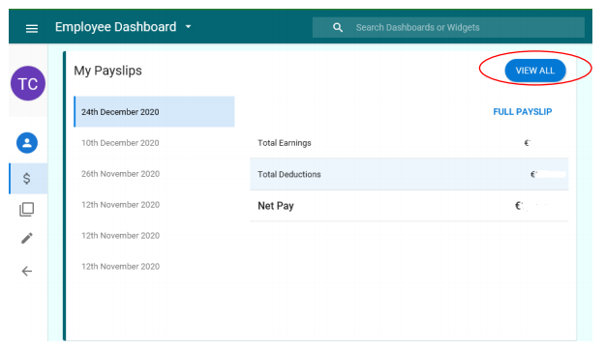

This will display previous payslips available on the system, displaying a screen similar to the following:

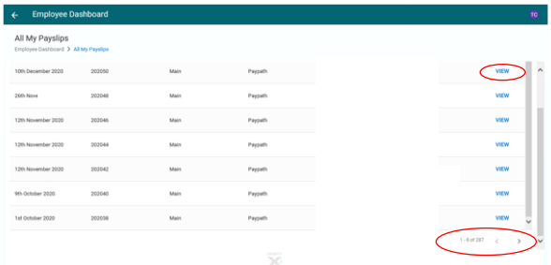

Click on the ‘view’ icon to the right of the required payslip to open it. Older payslips can be viewed by selecting the right arrow at the bottom of the page.

- The P60 Documents section is below My Payslips.

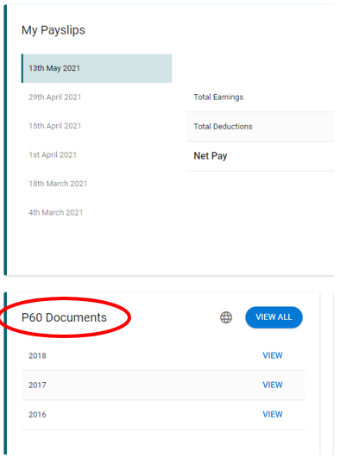
The more recent P60s can be viewed by clicking on View beside the relevant year. Earlier years can be viewed by clicking View All to the right of P60 documents and then clicking View for the relevant year.

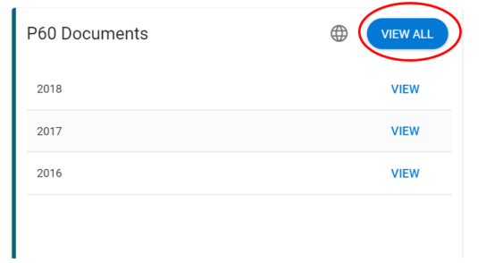

To print a P60, click on View to the right of the relevant year and the detailed P60 will be displayed.

To print the Standard P60 document click on the Generate P60 and the document will be displayed and may be printed.

The language in which the P60 is displayed may be changed by clicking on the globe symbol (which is between P60 documents and View All).

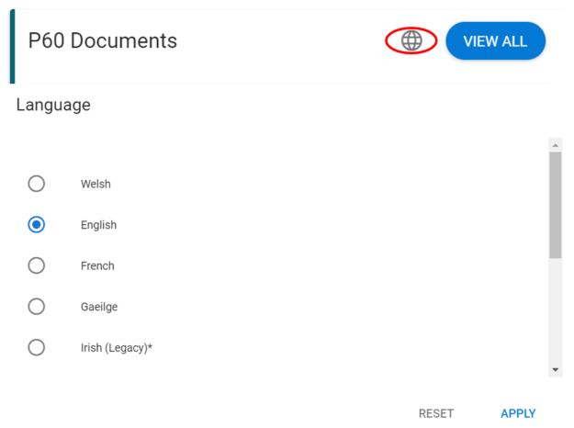
Important Information on P60s:

P60s from 2013 to 2018 inclusive are available on the system. From 1 January 2019, Revenue as part of their PAYE modernisation scheme have replaced the P60 with the Employee Detail Summary. This will be available to every person on their Revenue Online Account.

The Employee Detail Summary will display payments made to the employee from all employments/relevant pensions in addition to their statutory deductions. Assistance in viewing your Employee Detail Summary can be received from Revenue by contacting them through your account or by emailing roshelp@revenue.ie

Top Tip! Your week 52 (end of year payslip) is useful as it will contain cumulative year to date figures for deductions taken from your payroll during the year.

- When you have finished using the system, please Log Out by clicking on your initials at the top right-hand corner of your screen and click Log Out.

RCPSA May 2021

