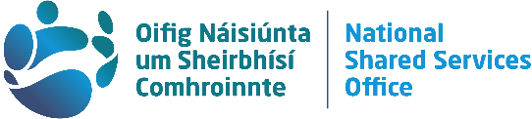 | Employee Services  National Shared Services Office

Dear Colleague

The National Shared Services Office (NSSO) is raising awareness of the variety of cyber threats and fraud risks we all need to be on the lookout for; through our Fraud and Cyber Security Awareness Campaign.

Each one of us needs to be vigilant in protecting our personal information as fraud and cyber security issues are a real concern; for the NSSO, for our customers using our services and our staff. We are encouraging you to please be wary of the following;

Organisation Replication fraud
Beware of being invited via email to enter any NSSO website (nsso.gov.ie, pssc.gov.ie and peoplepoint.ie ).

You may be asked by scammers to click on a link for an urgent update or to validate pay details. There are a number of scams operating at present, and clicking on strange links or websites could download malware, or result in a bitcoin ransom.

Advice:
The NSSO will not contact you in this way, unless you are required to register on our Portals.

Phishing
Beware of strange emails, texts or phone calls purporting to be from the NSSO looking for personal information.
Advice:
• Don’t click on unusual links
• Do not divulge personal information

The NSSO does not initiate contact with a customer and ask for personal information online.

If you receive a suspicious text message or strange email alluding to be from the NSSO, please alert your office’s IT Helpdesk. Please also email the NSSO at help@nssoitsupport.cloud.gov.ie to alert us of the attempted fraudulent activity.

For customers without access to an IT Helpdesk we advise deleting suspicious emails and keeping your Anti-Virus up to date. In the NSSO we take cyber and fraud risks very seriously and we have stringent procedures in place to protect our customers’ and our own data.

The NSSO, as an all-of-Government shared services provider, partners with all Government Departments and a range of Public Service Bodies (currently 55) including An Garda Síochána, Military and Prison Services, providing the administration of HR and pensions services for 38,400 civil servants, and Payroll and related services for 144,300 public servants, including 60,000 pensioners.

In 2020, while continuing to provide services during the pandemic, the NSSO completed 182,500 HR transactions and 1.5 million digitised automated transactions. We answered 56,000 customer calls, over 112,000 contact centre emails and were responsible for pension and payroll payments valued at over €5.5 billion.

More information on the NSSO is available from nsso.gov.ie

Regards,
National Shared Services Office (NSSO)
April 2021

