Status update from the NSSO, up to Pay period 52 of 2020
Reproduced by kind permission of the NSSO
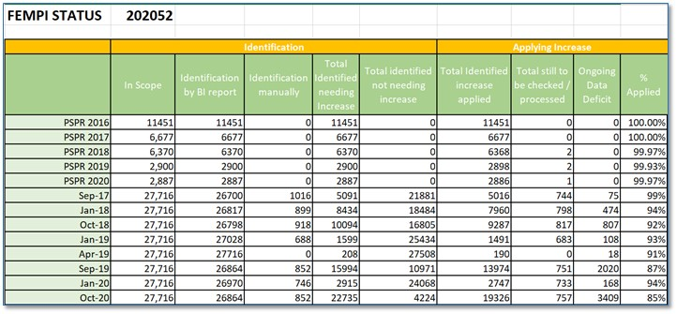
NOTES:
1 There are still some issues outstanding regarding increases to Prison Officer pensions. These are being followed up with DPER by the NSSO.
2 As yet we do not have a full list of Fixed and Variable Allowances. Again, this is being followed up with DPER by the NSSO. In general, variable allowances have been identified as allowances which are calculated as a percentage of pay. Some fixed allowances have been identified and an increase paid where appropriate.

