ACCESS TO PAYSLIPS FOR PUBLIC SERVICE RETIREES

The NSSO has been working on their online system in an effort to make access to online payslips more user friendly. The following is a guide to viewing payslips online on the Payroll Shared Services Centre (PSSC) website. Thank you to the staff of the PSSC for their assistance in compiling this information and providing sample screenshots.

1 Go to the website https://pssc.gov.ie/ (note: do not put www before it; you can just type pssc.gov.ie)

2 Select the Option ‘View Retiree Online Payslips’
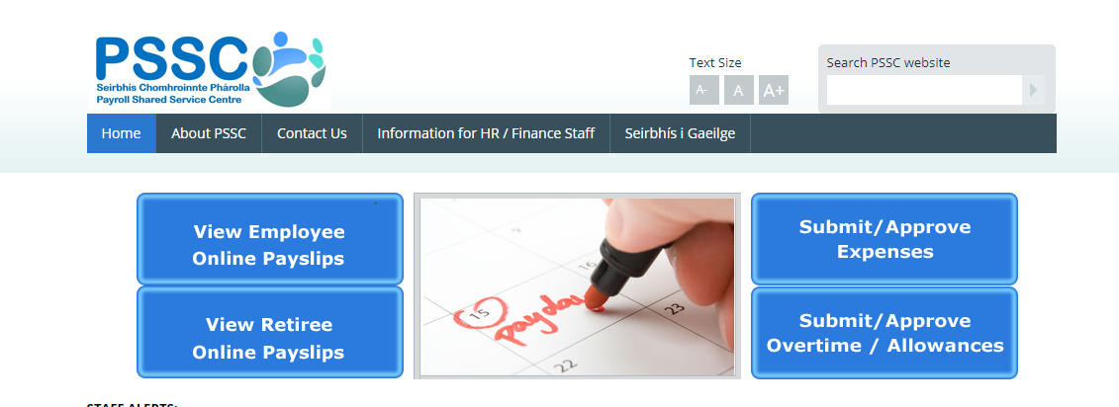

3 Select your option from the list:
Unless you are a retired Garda Siochana or a Military retiree, click on Civil and Public Service Retirees.

4 Enter your Employee Number (ie your 7-digit Personnel Number which is available on the top lefthand corner of your payslip) and your Password and click Sign In. If you have forgotten your password, contact helpdesk@pssc.gov.ie. You will be required to change your password every 6 months, so keep a note of your latest password.

If you are required to change your password, you will be asked to enter your current password, then enter your new password and confirm it. Your new password must be a minimum of 5 characters, consisting of a combination of numeric and letter values. The password must vary from any password set previously for the account.

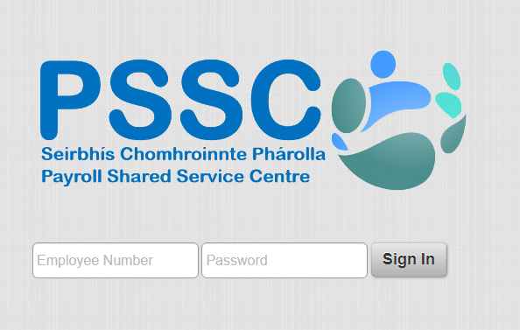
5 When you have successfully logged in, you will be on a My Payslips screen. This shows a summary of your four most recent payslips (or three most recent and your next payslip, depending on the timing), and also gives you access to your pension P60 details for years prior to 2019. Historic pension information can be accessed by clicking on the magnifying glass symbol – more details below.

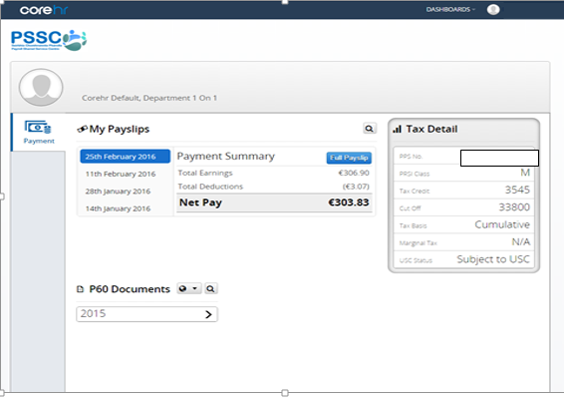

6 To see more details on your current payslip or on another recent payslip, click on the relevant date then click on “Full Payslip” to open it fully.

This will display the detailed payslip for the selected period in a new window. You can change the language to Irish by selecting the “Gaeilge” option at the top left of the screen.

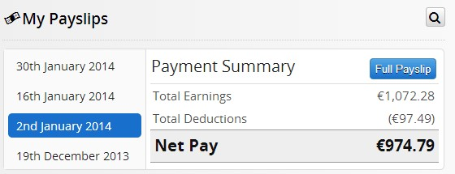

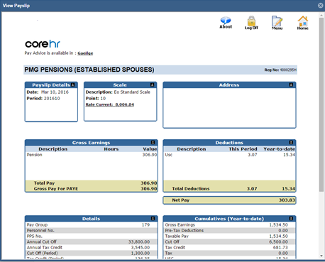
Pressing the “View Print Version” button when you scroll to the bottom of the screen will allow you to print the payslip.
7 As mentioned above, Historic Payslips can be accessed by clicking on the magnifying glass symbol on the My Payslips screen.

This will display previous payslips available on the system, displaying a screen similar to the following:
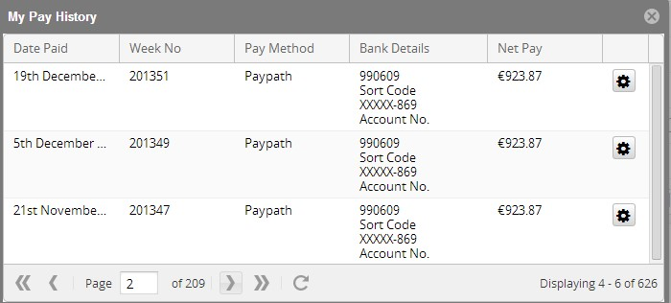

Click on the cog icon to the right of the required payslip to open it. Older payslips can be viewed by changing the screen (selecting the right arrow) at the bottom of the screen. You can also access historic payslips if you click on Back at the end of the detailed payslip screen.

8 P60s are available on the My Payslips screen for previous years, up to and including 2018, in both Irish and English. To view P60s in Irish click on the button highlighted below (a). To print a P60, click on the relevant year and the screen shown at (b) will be displayed, detailing all the relevant P60 details. To print the Standard P60 document click on the Generate P60 and the document will be displayed and may be printed.

(a)
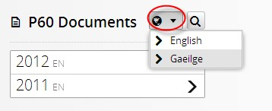

(b)
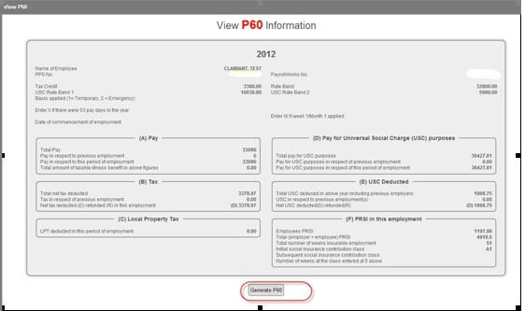

9 Historic P60s can also be viewed by clicking on the Magnifying Glass within the P60 Documents section.

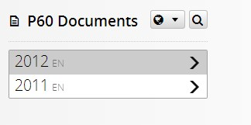

This will display previous P60s available on the system, displaying a screen similar to the following:
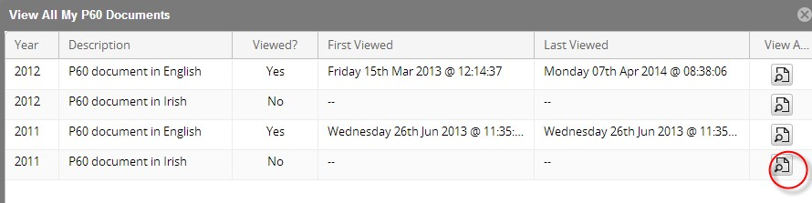
Click on View P60 as per the highlighted symbol to print previous P60s.

10 When you have finished using the system, please Log Out by clicking on your Name on the top right-hand corner of your screen and click “Log Out”.

